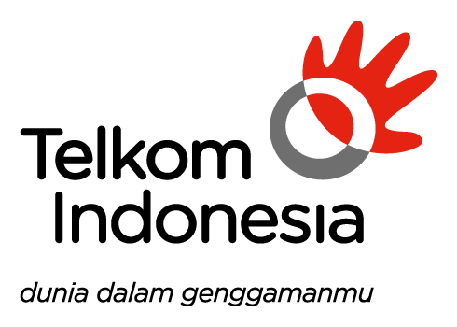

*PERSONAL IDENTIFIABLE INFORMATION*

***TIDAK ADA AKTIVITAS PERTUKARAN DATA***

***PERSONAL IDENTIFIABLE INFORMATION (PII)***